Contents
1 Introduction 3
1.1 Purpose and Scope 3
2 Design Overview 3
2.1 Changes Required 3
3 Detailed Design 4
3.1 Timeout Calculation 4
3.2 New Class CShutdownTimer 4
3.3 CServShutdownServer::SwitchOff() 6
3.4 Start the Timer 7
3.5 Final Design 9
3.5.1 Class Diagram 9
3.5.2 Sequence Diagram for Restart Event 10
4 Further Information 12
4.1 People 12
4.2 References 12
4.3 Open Issues 12
4.4 Glossary 12
4.5 Document History 12

Introduction

Purpose and Scope
This document describes the changes required to Shutdown Manager (pwrcli) in order to fix the defect DEF111025 “Device restarts from PREQ1089 UIF functionality can be delayed indefinitely”.
The target audience that this document is intended includes the TA and engineers within System Libraries, UI Frameworks, Test Engineering and the PM responsible for the defect fix.

Design Overview
DEF111025 complains that when the LAF Shutdown Manager requests the Base/EIK Shutdown Server to handle Shutdown/Restart events, clients of the Shutdown server are able to delay the shut down sequence by using the call CSaveNotifier::DelayRequeue() and then never calling CSaveNotifier::Queue().
To prevent this indefinite delay, a time-out limit is placed on the shutdown handling sequence. If all clients finish the data saving and call CSaveNotifier::Queue() to re-register before the time-out expires, the Shutdown/Restart will continue from this point. If the time-out expires before the clients complete the data saving, Shutdown/Restart will continue regardless.
The timer will apply to all save types (except ESaveNone) and any power state,
As well, we found the server will cancel the shutdown/restart process when an error occurs on client side. This must be changed so that the shutdown/restart process can keep executing in any case.
For a minimum code and API change, the time limit would be calculated by 2 constants (see the formula in section 3.1), instead of specified as API parameters, which needs to change existing API and break the source compatibility and binary compatibility. These 2 constants will be patchable data for providing the interface to the licensees to define specific values when building the ROM image.

Changes Required
The high level changes required to fix DEF111025:
- 2 constants will be defined in shutdownsrvpatchdata.cpp as global variables with default values to be the parameters for calculating the time-out. Macro controlled patchdata directives will be added to pwrcli.iby to allow licensee to set their vaules.
- The timer class CShutdownTimer will be introduced. It is derived from CTimer. Its RunL() executes the Shutdown / Restart by calling CServShutdownServer::SwitchOff() when timeout expires.
- CServShutdownServer::SwitchOff() will be changed to be public so that it can be called by CShutdownTimer. As well, it should not really power down the system in test mode to allow the ONB(Overnight build) to run the test program automatically.
- Use class CShutdownTimer. This class is declared as a member data of CServShutdownServer. It will be initialised in CServShutdownServer::ConstructL() if applicable and released by CServShutdownServer’s destructor. As an active object, it should be added to and removed from the active scheduler list at appropriate moments.
- The server should not cancel the shutdown process when the client reports an error.
- To test the changes, test program will query about the server’s power state. The server must handle the query request for test purpose.

Detailed Design

Timeout Configuration
2 constants will be defined in shutdownsrvpatchdata.cpp as global variables with default values.

EXPORT_C extern const TInt32 KShtdwnTimeoutBase = 1000000;
EXPORT_C extern const TInt32 KShtdwnTimeoutClient = 500000;

The timeout will be calculated as:
timeout = KShtdwnTimeoutBase + (KShtdwnTimeoutClient * numClients)
where numClients is the number of connecting clients.
The timeout is calculated as:
KShtdwnTimeoutBase + KShtdwnTimeoutClient * numClients,
where numClients is the number of connecting clients.

If the timeout value is;
- -1, the timer is not used, the server will wait for all client's registration before executing the shutdown;
- 0, the timer expires immediately, the server will execute the shutdown immediately, not waiting for any client's re-registration.
- other value greater than 0, the server will wait a certain period of time for the clients' registration and execute the shutdown if the timer expires or all clients re-register.

The above constants are patchable data. Command “patchdata” will be added to PwrCli.iby to reset these 2 values:

#ifdef SYMBIAN_PWRCLI_PATCHDATA_KSHTDWNTIMEOUTBASE
patchdata shutdownsrv.dll@KShtdwnTimeoutBase SYMBIAN_PWRCLI_PATCHDATA_KSHTDWNTIMEOUTBASE
#endif
#ifdef SYMBIAN_PWRCLI_PATCHDATA_KSHTDWNTIMEOUTCLIENT
patchdata shutdownsrv.dll@KShtdwnTimeoutClient SYMBIAN_PWRCLI_PATCHDATA_KSHTDWNTIMEOUTCLIENT
#endif

Licensees who wish to alter them will need to define these ROM build-time macros in their product HRH or IBY files
The new values must follow the rule:
KShtdwnTimeoutBase >= -1 and
KShtdwnTimeoutClient >= 0.
Otherwise, CShutdownTimer::NewL() panics with KErrNotSupported.

Timer Class CShutdownTimer
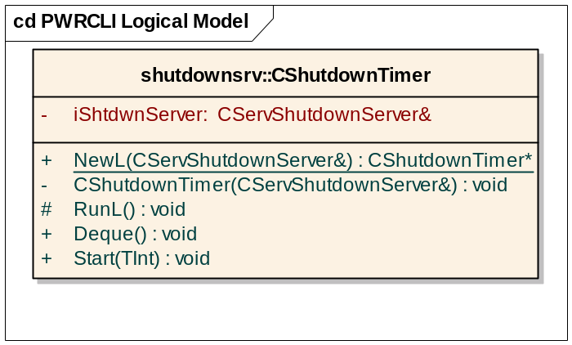
CShutdownTimer is derived from CTimer, which encapsulates the RTimer already. Its constructor receives the reference to the CServShutdownServer and stores it in data member iShtdwnServer.
Its NewL() is a 2-phase constructor to create the object if applicable. It will check the configuration of the patchable constants to determine whether to create the timer object. It might return a null pointer to indicate the timer is configured not to be used.
Runl() will be called when timeout expires. It calls CServShutdownServer::SwitchOff() to perform the shutdown/restart.
The overwriting method Deque() will check whether this active object has been added to the active scheduler before Dequing.
Start() calculates the timeout value by the number of the clients and the patchable constants and starts the timer.

CServShutdownServer::SwitchOff()
CServShutdownServer::SwitchOff() needs to be public so that CShutdownTimer::RunL() can call it.
To allow the ONB runs the test program automatically, it should not really power down the system in test mode (flagged by the definition of SYSLIBS_TEST). Instead, it only prints a debug message.

Usage of CShutdownTimer
- Create the timer
CServShutdownServer::ConstructL() call CShutdownTimer::NewL() to initialise the timer object.
- Start the timer
If the timer should be used, CServShutdownServer::NotifySave() will call CShutdownTimer::Start() to start the timer after sending notification to all clients

- Remove the active object from the active scheduler.
The shutdown process can be cancelled by the server. CServShutdownServer::SwitchOff() might be triggered because all clients re-register themselves. In these 2 cases, CShutdownTimer object should be removed from the active scheduler. We will call CShutdownTimer::Deque() in 2 methods: CServShutdownServer::SwitchOff() and CServShutdownServer::CancelPowerOff().
CServShutdownServer::SwitchOff() might be triggered because all clients re-register themselves or the timer expires.

- Release the object
The CShutdownTimer object will be released by CServShutdownServer’s destructor.

Client’s Error Handling
When error occurs on client side, it will send request TSaveOpCodeHandleError to the server by calling CSaveNotifier::HandleError() or making MSaveObserver::SaveL() leave.
Under the latest design of this component, the server will ignore the error instead of cancelling the shutdown. So CServShutdownSession::DoServiceL() will leave with KErrNotSupported and CServShutdownSession::HandleSaveErrorL() should be deleted.
On client side, it makes no sense to report an error which will not be handled by the server. So CSaveNotifier::RunL() will not call RSaveSession::HandleSaveError() even if MSaveObserver::SaveL(). As well, CSaveNotifier::HandleError() will not call RSaveSession::HandleSaveError(). It will be remained only to maintain SC and BC but marked as “deprecated”. Thus, RSaveSession::HandleSaveError should be deleted because no other method calls it.

Changes testability
To ensure the shutdown has been executed by the timer, the test program needs to query the power state of the server. To do this, it calls the new method CSaveNotifier::ServerPowerState(TBool& aPowerOff). The new method sends a new request code TSaveOpCodeQueryPowerState to the server.
CSaveNotifier::ServerPowerState() is a private method. CSaveNotifier should define the test classes as its friends to expose the private methods to them.
On server side, CServShutdownSession::DoServiceL() must handle the new request TSaveOpCodeQueryPowerState which is only sent by the test program. It calls the new method PowerStateL() to set the power state to the message. PowerStateL() will panic if SYSLIBS_TEST macro is not defined.

Final Design

Class Diagram
The class diagram of the component for the final design will be as follows:
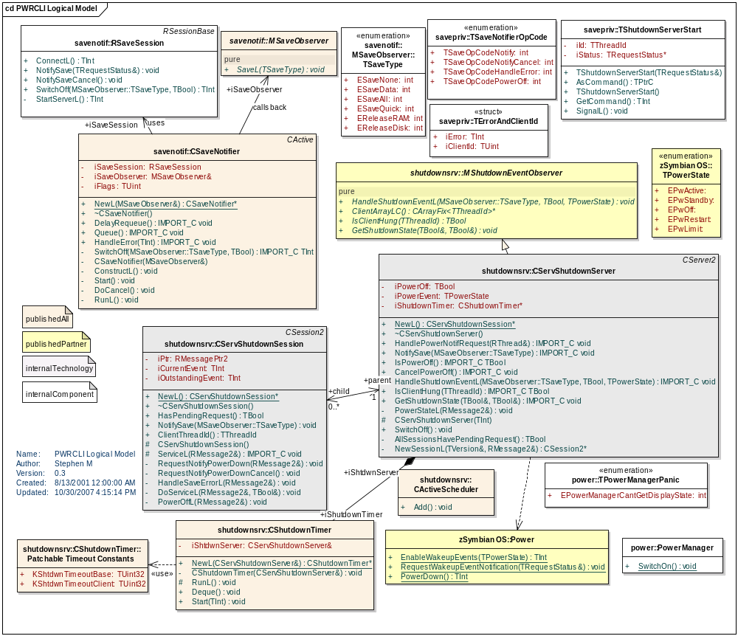

Sequence Diagram for Restart Event
The sequence diagrams for a restart event will be as follows
Diagram 1 shows the scenario that the timer expires before all clients re-register.
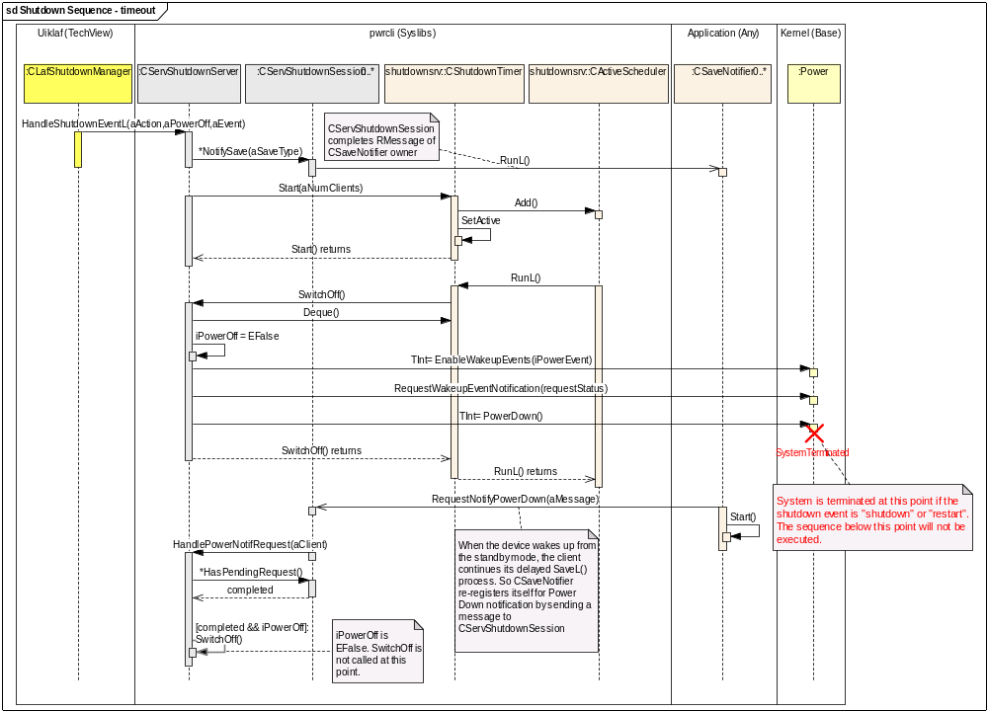
- CLafShutdownManager will call HandleShutdownEventL( ESaveAll, ETrue, EPwRestart)
- HandleShutdownEventL will save EPwRestart in iPowerEvent and call NotifySave.
- CServShutdownServer::NotifySave will in turn call all CServShutdownSession’s NotifySave()’s.
- CServShutdownSession::NotifySave() will complete pending requests, triggering CSaveNotifier’s RunL()’s.
- CServShutdownServer::NotifySave will start the timer CShutdownTimer.
- CSaveNotifier::RunL() will handle application specific save operations and then re-register for power-down notifications by sending a message to CServShutdownSession.
- CServShutdownSession’s ServiceL() will process the message and RequestNotifyPowerDown() will be called.
- RequestNotifyPowerDown() will call CServShutdownServer::HandlePowerNotifRequest().
- HandlePowerNotifRequest() will iterate through all registered CServShutdownSession’s to check if all of them re-registered by calling HasPendingRequest()
- In this scenario, the timer expires before all clients re-register themselves. SwitchOff() will be called by CShutdownTimer::RunL(),
- SwitchOff() will call Power API functions with the saved value of iPowerEvent to restart the device.
- If it is a standby event, the clients will continue to re-register themselves after the device is waken up. But SwitchOff() will not be called because iPowerOff is EFalse.

Diagram 2 shows the scenario that all clients re-register before the timer expires.
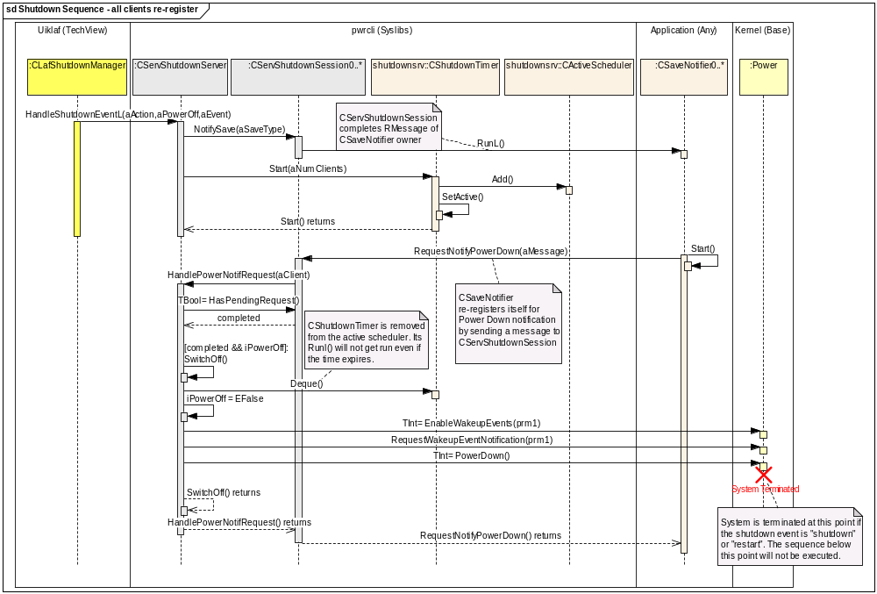
Steps 1 to 9 are the same as scenario 1. From Step 10:
In this scenario, all clients re-register themselves before the timer expires. SwitchOff() will be called by CServShutdownServer::HandlePowerNotifRequest.
SwitchOff() will call Power API functions with the saved value of iPowerEvent to restart the device.
SwitchOff() has called CShutdownTimer::Deque() to remove the timer object from the active scheduler. The timer stops counting So CShutdownTimer::RunL() will not run.

Further Information
None.

People
Role | Person / People
Reviewers | Stephen Mansfield, Phil Hodgson, Aleks Pamir
Contributors | Kevin Guo

References
No. | Document Reference | Version | Description

Open Issues
None

Glossary
Term | Definition

Document History
Date | Version | Status | Author | Description
08-11-2007 | 1.0 | Issued | Kevin Guo | Issued
30-10-2007 | 0.3 | Draft | Kevin Guo | Updated
24-10-2007 | 0.2 | Draft | Kevin Guo | Updated based on the review
04-09-2007 | 0.1 | Draft | Kevin Guo | First draft based on SGL.TS0017.654 Impact Analysis of DEF111025.doc

